**Section 5: Distributing Load Using AWS Elastic Load Balancing:**

**37. Step 01 - Getting started with Load Balancing - AWS Elastic Load Balancing**

* ELB is service provided by AWS that enable us to distribute load among multiple EC2 instances, so we can create n number of EC2 instances and distribute the load using AWS ELB.
* These EC2 instances can be in multiple availability zone (AZs) within the same region (like Mumbai Region but multiple zones)
* ELB is a managed service, so once you create ELB then AWS would ensures that it is up and running i.e. highly available.
* ELB load balancer loads automatically scales to handle huge loads.
* ELB can be public (accessible over the internet) or private (Accessible to specific internal AWS network)
* The most imp things of ELB is that it distribute the loads only to the Healthy instances i.e. we can configure Health check at ELB which continuously checking health of EC2 and send the request only if they are up and running.

|  |  |
| --- | --- |
|  | In short:  Distribute traffic across EC2 instances in one or more AZs in a single region    **Managed service** - AWS ensures that it is highly available Auto scales to handle huge loads    Load Balancers can be **public or private**  **Health checks** - route traffic to healthy instances |

There are five types of load balancer given by AWS.

**38. Step 02 - Understanding HTTP, HTTPS, UDP and TCP Protocols**

When we talk about virtual servers, load balancers or when we talk about communication between two systems then must talk about protocols like (http, https, UPD, TCP, and TLS etc).

**HTTP vs HTTPS vs TCP vs TLS vs UDP**

|  |  |
| --- | --- |
|  | As per the diagram whenever two system talks to each other then communication happens at multiple layers.  The important layers are [Application Layer (L7), Transport Layer (L4), and Network Layer (L3)].  Why do we need these layers? Let’s talk about it. |

* Computers use multiple protocols to communicate each other just like human being talk to each other in different languages. Each language has their own structure and syntax. In the same way when two computers talk to each other then need one common rule or syntax which is called protocol.
* So we have multiple protocols for Multiple layers
* **Network Layer** – Act as bridge among the computers and Transfer bits and bytes (0s & 1s). For example we communicates over the internet then we need multiple routers
* **Transport Layer** – this layer responsibility to ensure the bits and bytes transferred properly over the network among different routers.
* **Application Layer** – This run top of the chain among all the layers which Make REST API calls and Send Emails
* (**Remember**) Each layer makes use of the layers beneath it
* (**Remember**) Most applications talk at application layer. BUT some applications talk at transport layer directly to get high (high performance).

So as pre the diagram we can see that protocol used in different layers are>

**Network Layer:**

* IP (Internet Protocol): Transfer bytes. It is Unreliable layer, data might lost at this layer and that is why Transport layer comes

**Transport Layer:**

* TCP (Transmission Control): High Reliability > Performance: if one computer sends 10 byte then it ensures that on the other side computer receives the 10 byte in the same sequence
* TLS (Transport Layer Security): similar to TCS but as data travels over the network so it must be secured and that the TLS does i.e. Secure the TCP
* UDP (User Datagram Protocol): It is alternative to TCP and it gives high important to Performance over Reliability i.e. if one computer sends 100 bytes of data then it gives the important of sending the data ASAP and it is ok if other side computer receives 90 Bytes of data instead of getting complete 100 byte.

Example: Video streaming, here it is ok if we miss some byte of video streaming but streaming should be fast

**Application Layer:**

* HTTP(Hypertext Transfer Protocol): Stateless Request Response Cycle
* HTTPS: Secure version of HTTP and secure the communication by having certificates which are installed on server.
* SMTP: Email Transfer Protocol
* FTP

**Most applications** typically communicate at application layer

* Web apps/REST API(HTTP/HTTPS), Email Servers(SMTP), File Transfers(FTP)
* All these applications use TCP/TLS at network layer(for reliability)

**HOWEVER** applications needing high performance **directly** communicate at transport layer:

* Gaming applications and live video streaming use UDP (sacrifice reliability for performance)

**39. Step 03 - Exploring Types of AWS Elastic Load Balancers**

**Classic Load Balancer (**Operates at BOTH Layers 4 and Layer 7).

* So it is supporting Layer 4(TCP/TLS) and Layer 7(HTTP/HTTPS) protocols
* Not Recommended by AWS (So for certification perspective not required)
* Because As per the AWS supporting load balancing at same time at two layer is a mistake and that is why they separated load balancing into two different layers

**Application Load Balancer (operates at Layer 7 only)**

* New generation supporting HTTP/HTTPS and advanced routing approaches. It is highly flexible and widely used in AWS load balancing

**Network Load Balancer (Operates at Layer 4 only)**

* New generation supporting TCP/TLS and UDP
* This LB is recommended for Very high performance use cases

**40. Step 04 - AWS Elastic Load Balancing - Getting started with Classic Load Balance**

**Classic Load Balancer**

* **Older** version of ELB
* **Not recommended anymore**
* Supports TCP, SSL/TLS and HTTP(S) (Layer 4 and 7)
* **Demo**: Create a Classic Load Balancer <https://docs.aws.amazon.com/elasticloadbalancing/latest/classic/elb-getting-started.html>

Steps:

Step-1: Select the load balancer type: Click on the Load Balancer Navigation link for

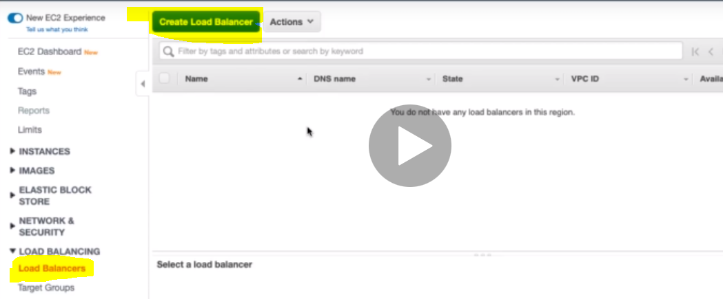

2- Click on button “Create Load Balancer” .It take us to the page where all the three types of load balancer is mentioned and since we are creating Classic load balancer so we will select Classic Load Balancer

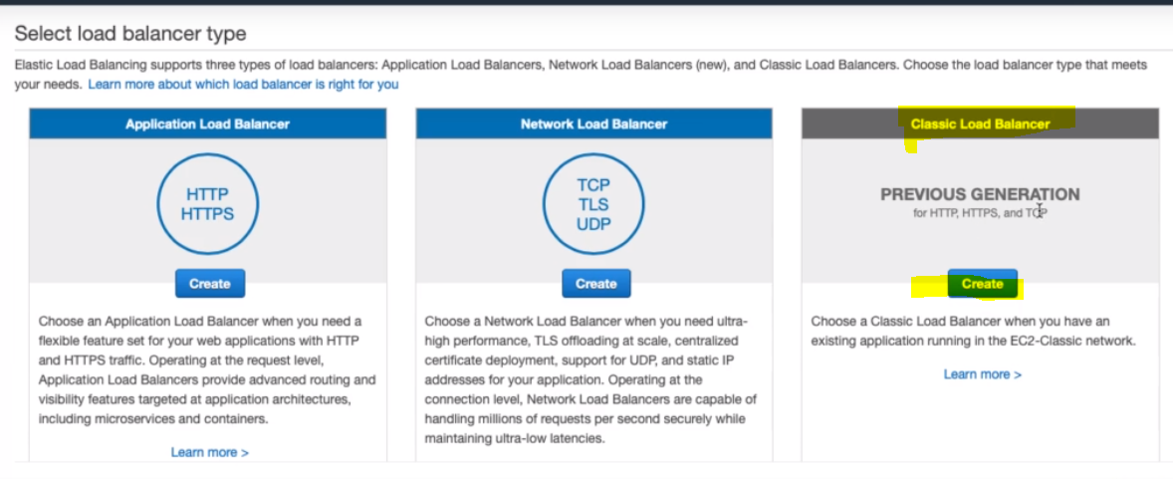

Step -1 Define Load Balancer

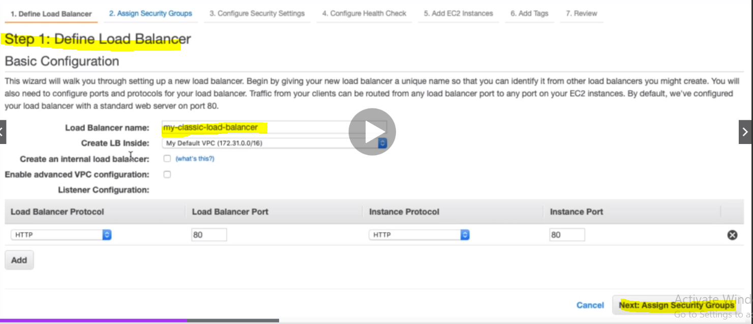

Now from this step Load Balancer Definition and configuration start. Let’s put the Classic LB name and then next assign security Group.

Whenever we create load balancer then we have to create inside some private network so here we have selected My Default VPC. Since we are creating public load balancer so we will not tick or check the “Create an Internal Load Balancer”. Similarly we are going to enable any advance configuration.

Finally let’s configure Load Balancer listener which will listen on port 80 with HTTP protocol i.e. will listen request to LB at port 80:

**Step2- Assign Security Groups**

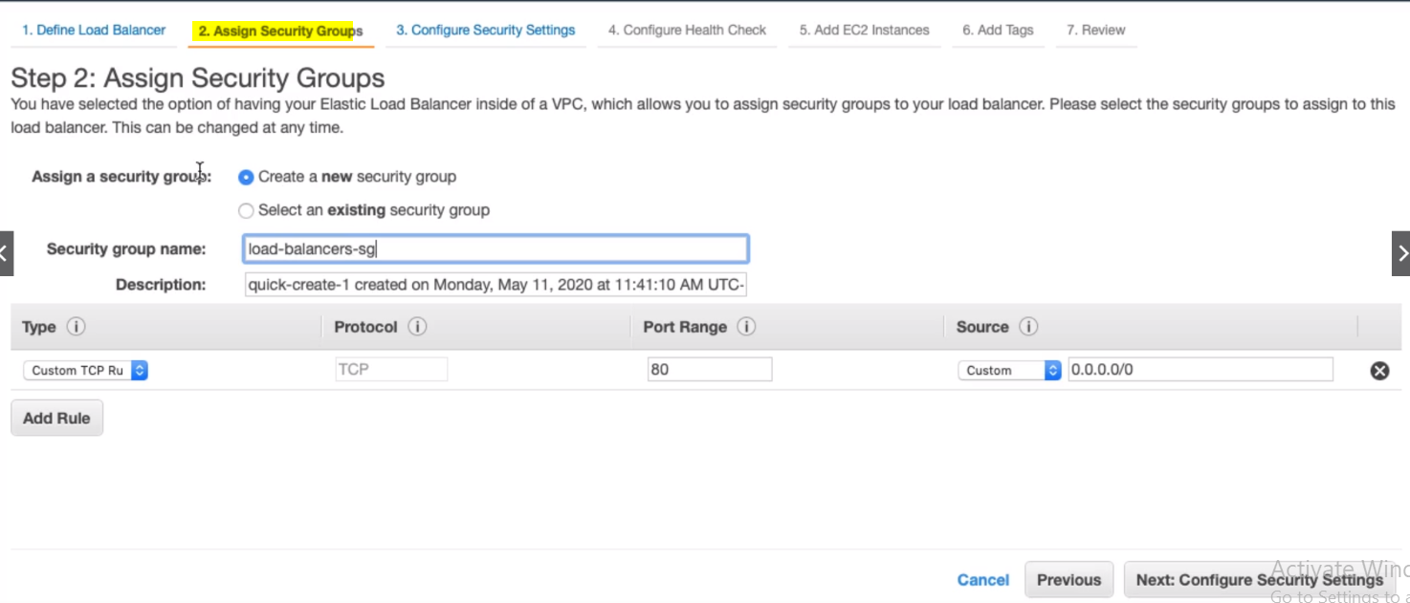Here instead of using existing security group, we will create new security group for load balancer and it is good practice to create a new security group for load balancer. And will use this security group name for other load balancer in future. And this SG should allow TCP protocol traffic at port 80 from everywhere (0.0.0/0). And now click next to configure security settings.

**Step -3: Configure Security Settings:**

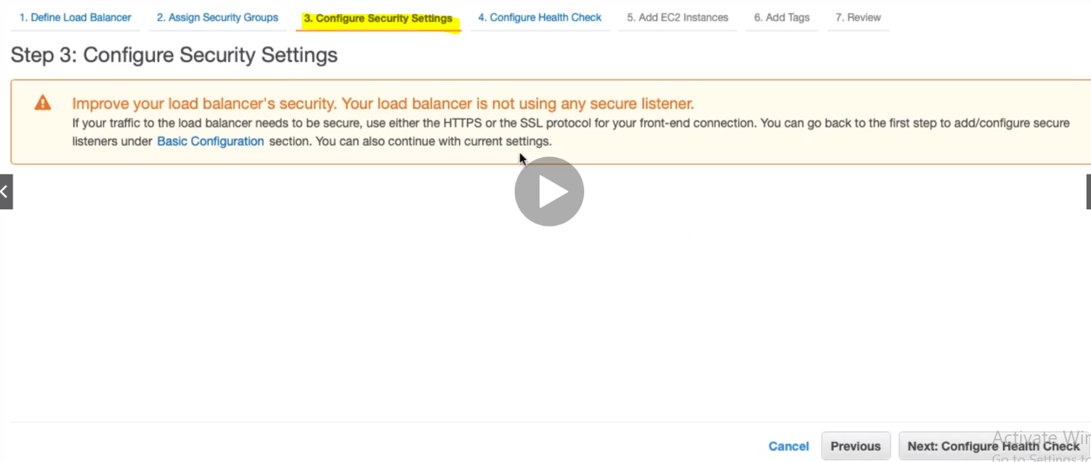Here we are getting advice to use HTTPS or SSL protocol for frontend connect to be secured. So now let’s go next and configure the Health check

**Step-4: Configure Health Check:**

Every LB automatically performs health check on our EC2 instances and only route the traffic to instances which pass the health check. If an instance fails the health check, it is automatically removed from the load balancer, we can customize the health check according to our needs.

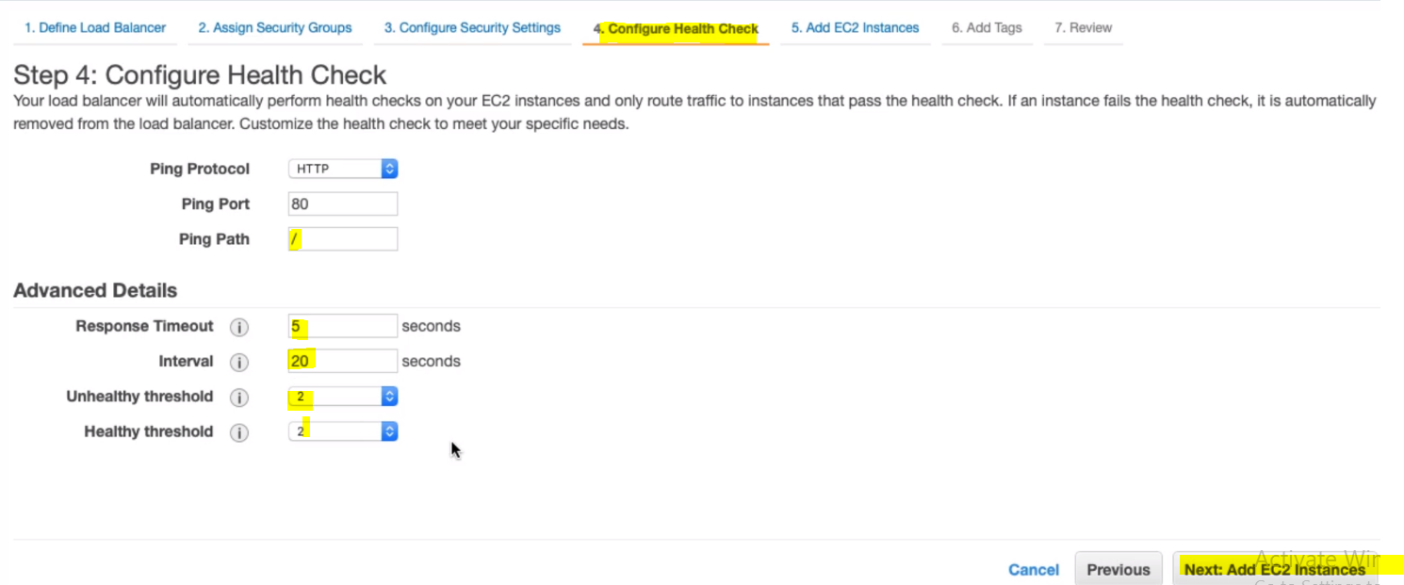

**Ping Path:** this is the path from where the LB will start check health check. So here in this case I have mentioned the health check to be started from rood (/)

**Response Time:** Time to wait to get response from the health check (2 sec to 60 sec)

**Interval:** Amount of time between healths checks (5 sec to 300 sec)

**Unhealthy threshold**: Number of consecutive health check failures before declaring an EC2 instance unhealthy.

**Healthy Threshold:** Number of consecutive health check successes before declaring an EC2 instance healthy

**Step5- Add the EC2 instances**

Finally at the end let’s add the EC2 instances to the load balancer.

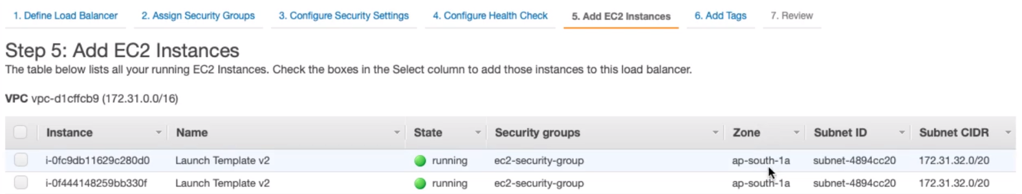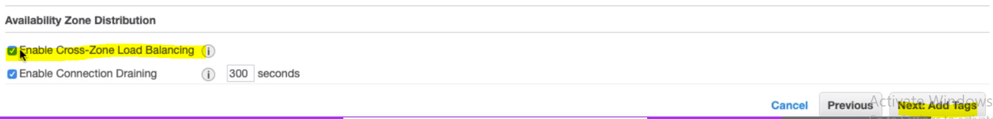

AS we can see that here we have two EC2 instances in running state and both the machine available in the same zone. We can add two EC2 instances available in two different zones with the load balancer, and for that we just have to check [**Enable Cross-zone Load Balancing**].

Whenever the load balancer finds that an instance is unhealthy and in that case health check will be failed for that instance, but it might be the case that the instance is busy in handling other request at that time currently and we don’t want the EC2 instance fail to process those request which are already in progress and if still issue persist then only LB will remove the instance, and for this we will have to enable [**Enable Connection Draining** for a particular time to complete in progress request, like here 300 sec] and only then it would terminate the EC2 from Load balancer.

Step6- Add Tags:

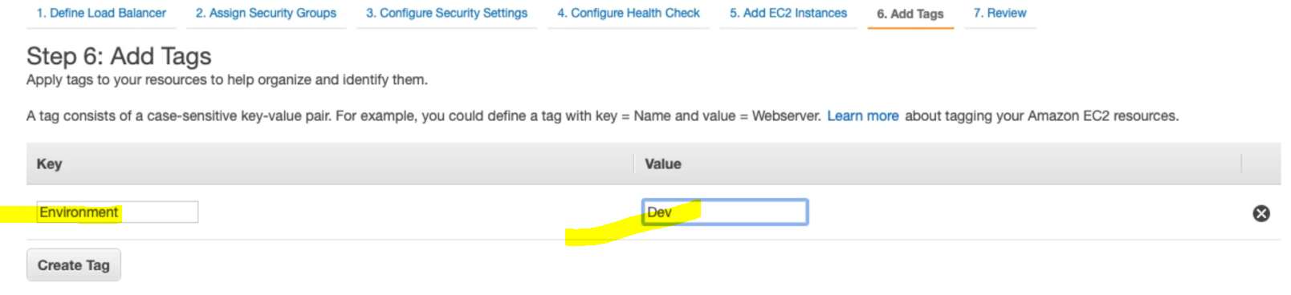



Step7- Review and Create:

Finally let’s create Load balancer.

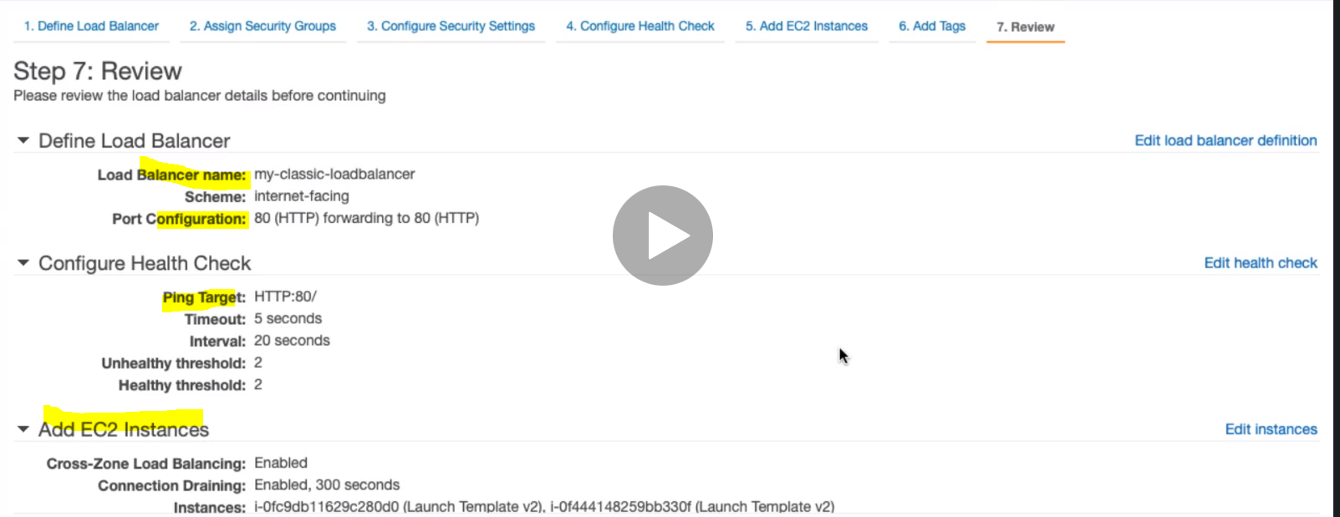

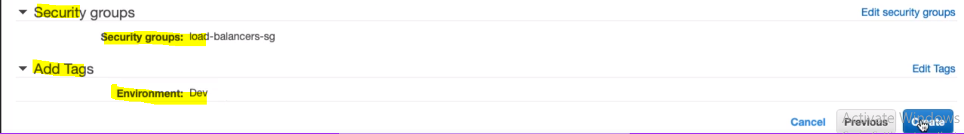

Finally click on button create:

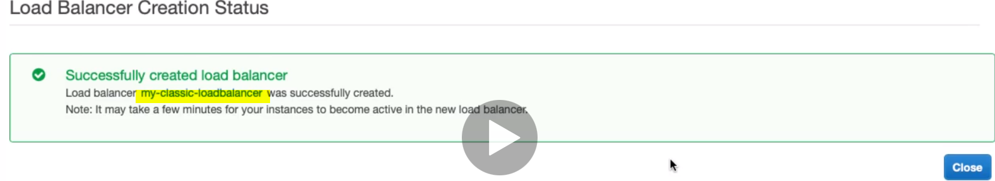

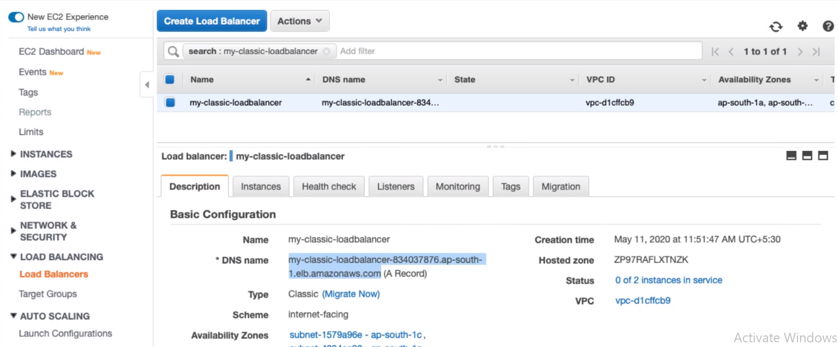

Finally the load balancer has got created.

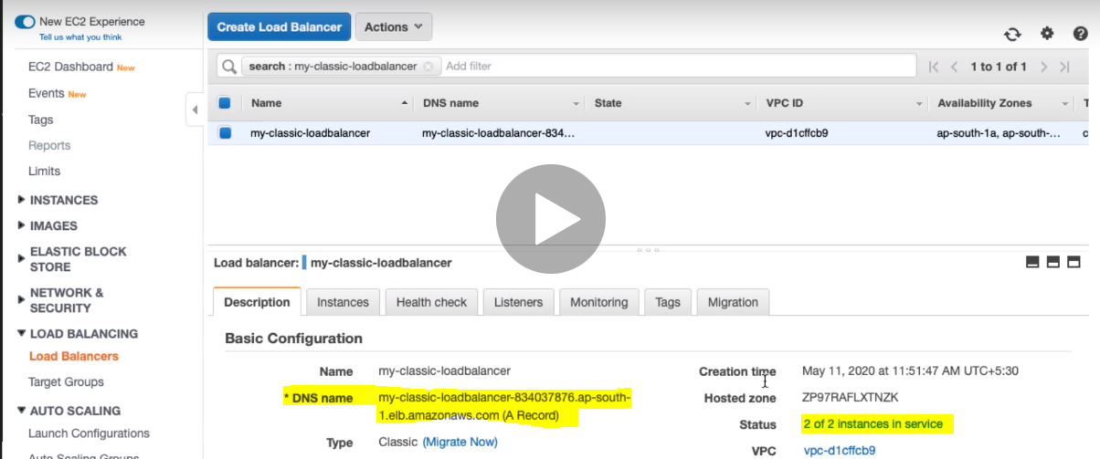

**41. Step 05 - Exploring Classic Load Balancer Further**

So now we can see two instances in service with load balancer in status and we have to DNS name of load balancer. And using this DNS name we can send the request to Load balancer which in-turn send the request further to one of the active healthy instance.

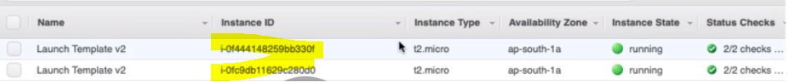

In the below image when we send request to LB using is DNS then send the request further to one of the instance whose instance id ends with 0d0 and private IP is : 172.31.41.189

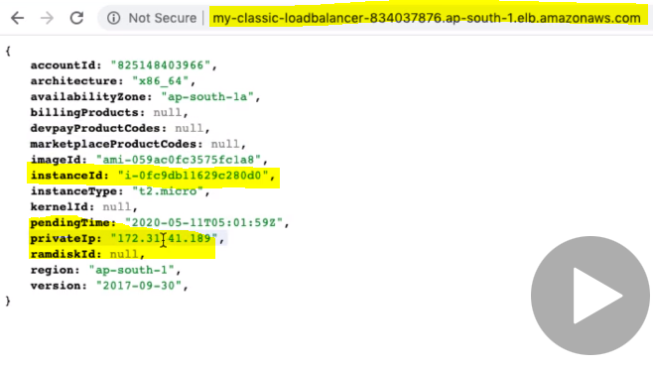

Now if we refresh the above page once again then LB send to request to other instance whose Instance id ends with 330f and private IP is : 172.31.35.39

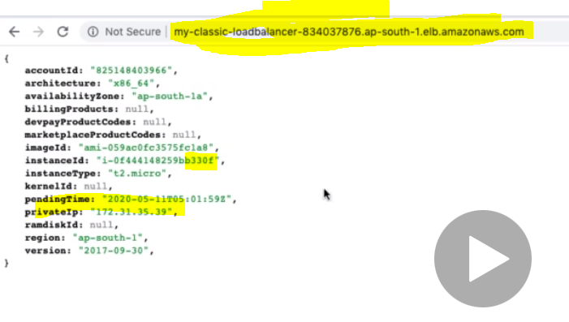

For comparison we can see both the Instance ID

So Classic load balancer working fine and balancing the load accordingly between the two instances.

Let’s see all the detail about Classic load balancer:

1. **Load Balancer Description**

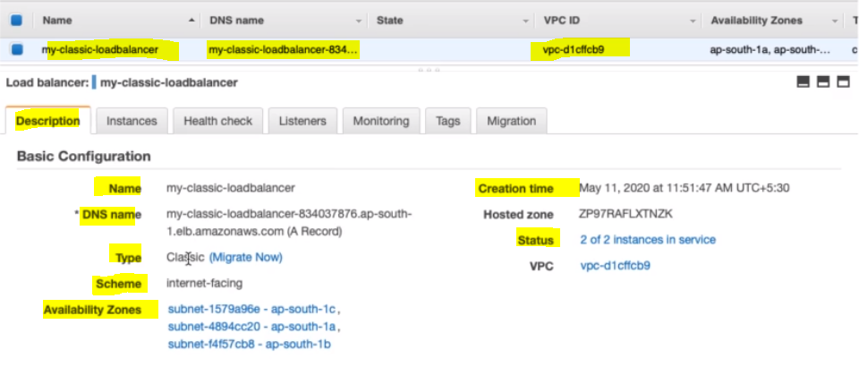

-------------------------------------------------------------------------------------------------------------------------------------------------------

1. **Classic Load Balancer Instances**

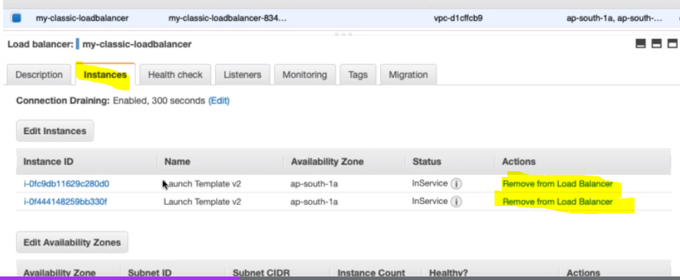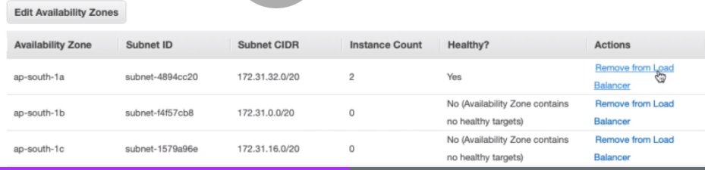

-----------------------------------------------------------------------------------------------------------------------------------------------------------

1. **Classic Load Balancer Health Check**

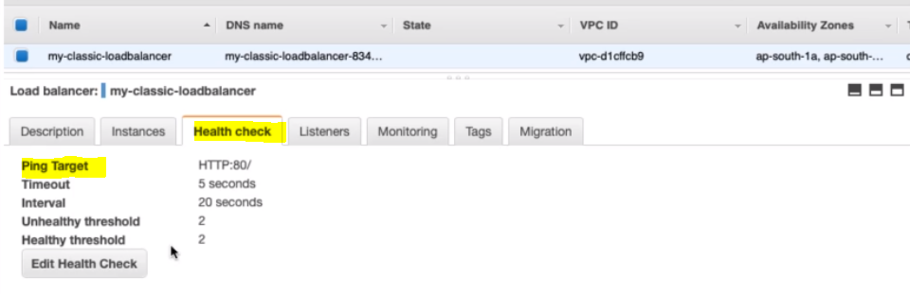

1. **Load Balancer Listeners detial**

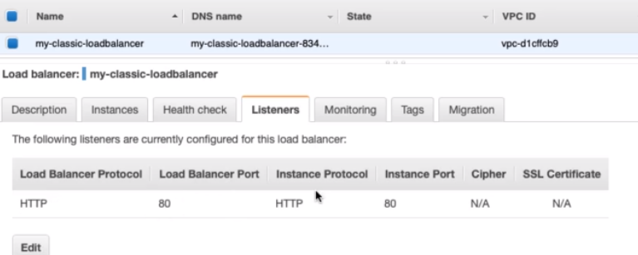

1. **Load Balancer Moniterting details**

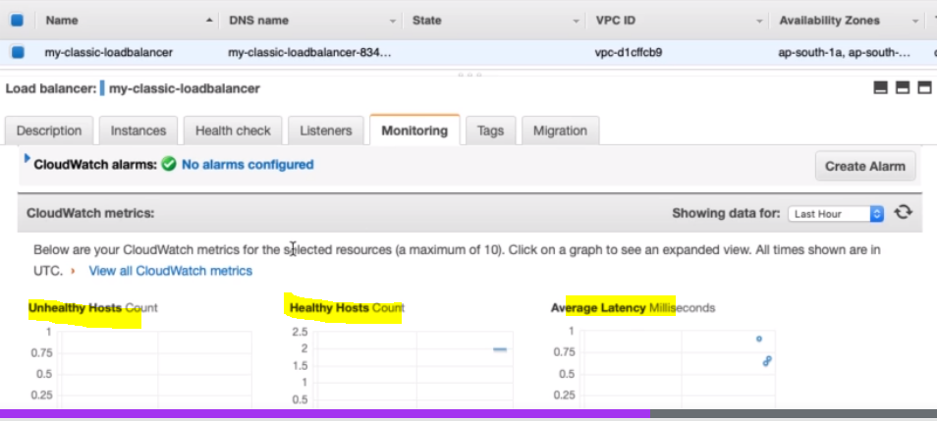 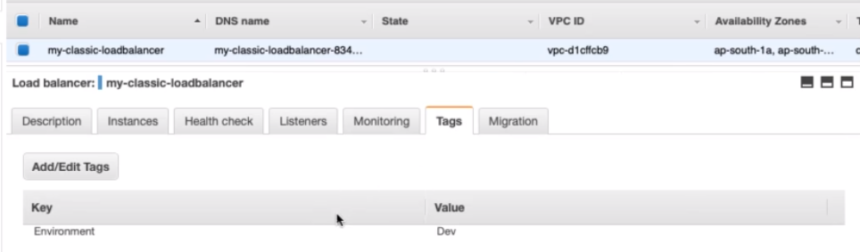

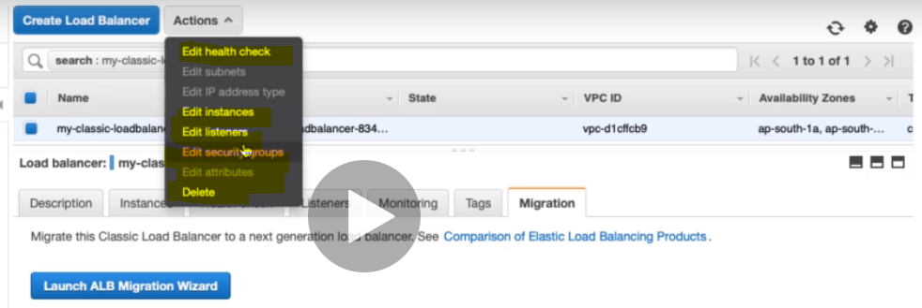

We can do the editing from the Actions of the load balancer also. and we can delete the classic load balancer.

**42. Step 06 - AWS Elastic Load Balancing - Getting started with Application Load Bal**

**Application Load Balancer:**

* **Most popular** and frequently used ELB in AWS
* Supports Web Sockets and HTTP/HTTPS (Layer 7) so basically it works at application layer
* Supports all important load balancer features
* Scales **automatically** based on demand (Auto Scaling). Since AWS Load balancer is managed service so whenever required AWS takes care auto scaling, while to auto scale of EC2 instances is the responsibility of users
* Can load balance between:
* EC2 instances (AWS)
* Containerized applications (Amazon ECS service is for container based application)
* Web applications (using IP addresses)
* Lambdas (serverless architectures)

**Demo:** Create an Application Load Balancer

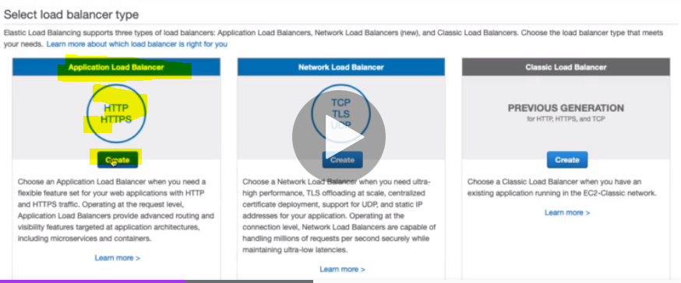

Application Load Balancer provide advanced routing and visibility features targeted at application architectures including microservices and containers.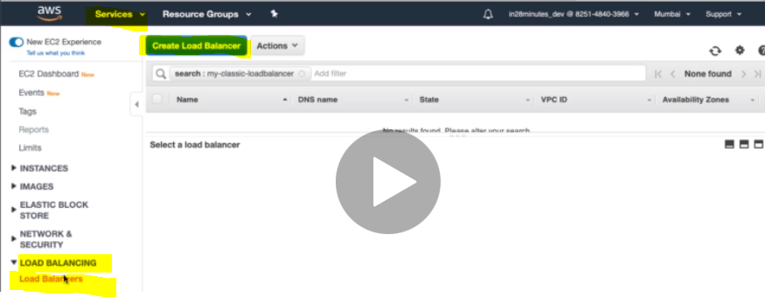

Step1- Configure Load Balancer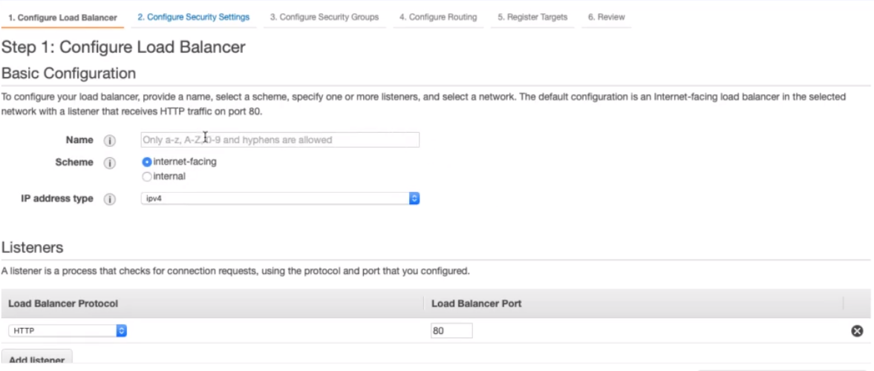 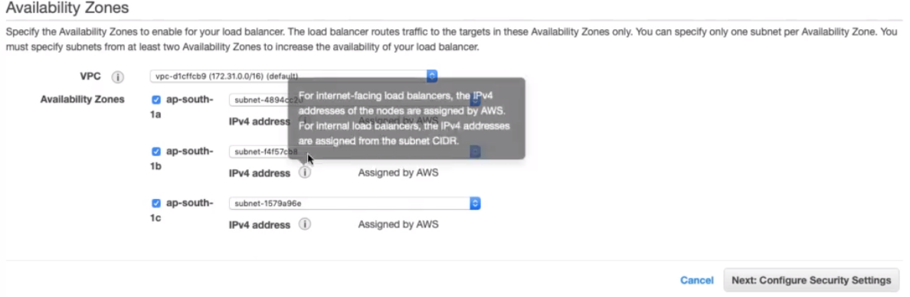

By default listeners is configures and listening at port 80.Here by default cross zone availability is enabled and we cannot disable.

**Step2- Configure Security Settings:**

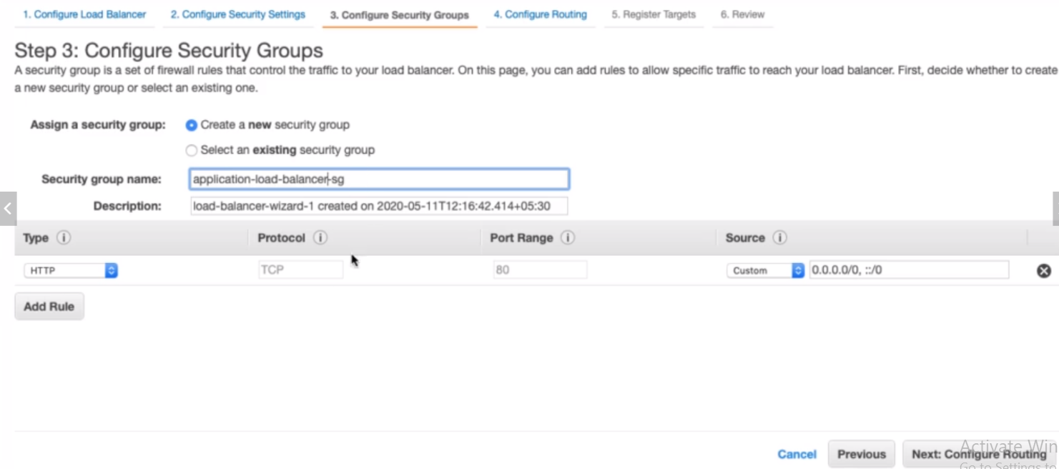

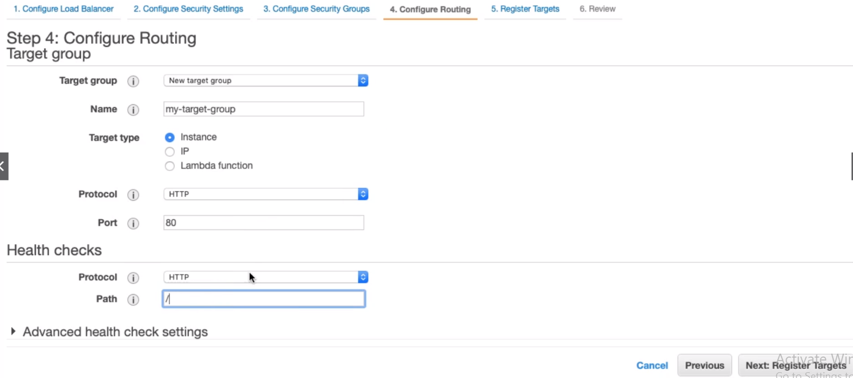 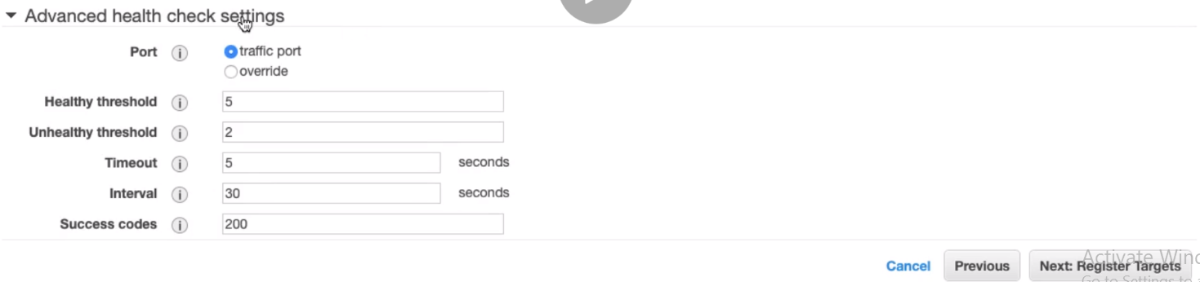 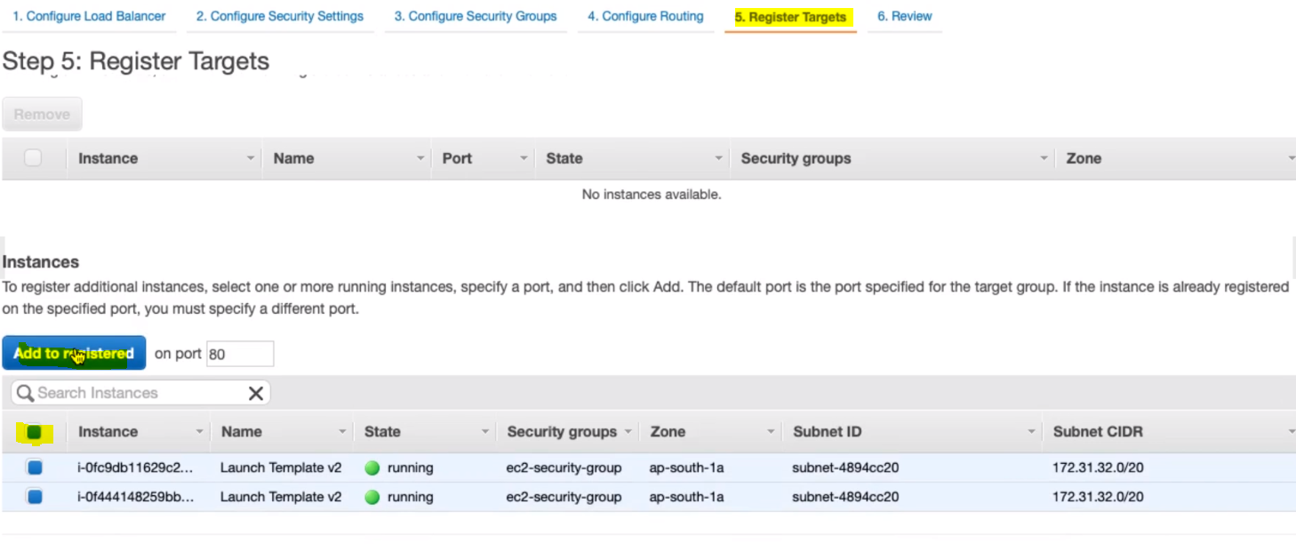

Finally let’s review and create the Application load balancer:

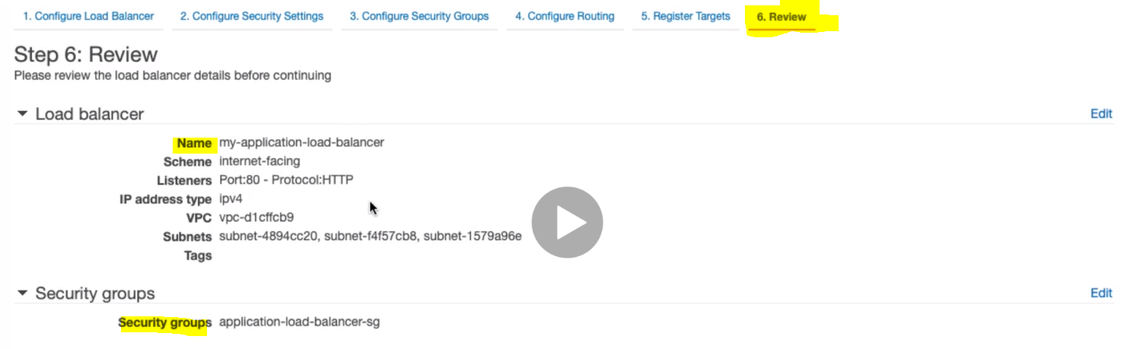 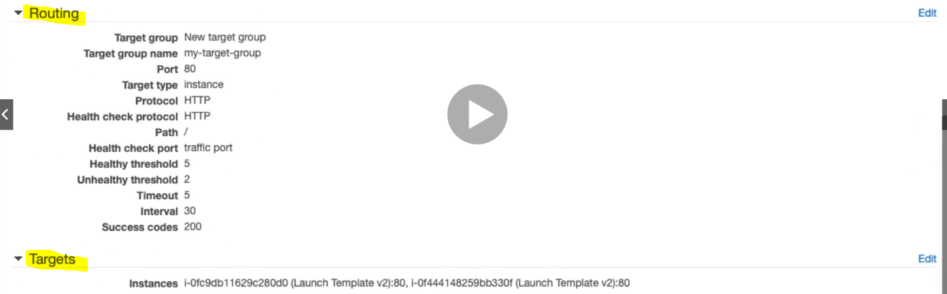

Click on create button

**43. Step 07 - Exploring Application Load Balancer Further**

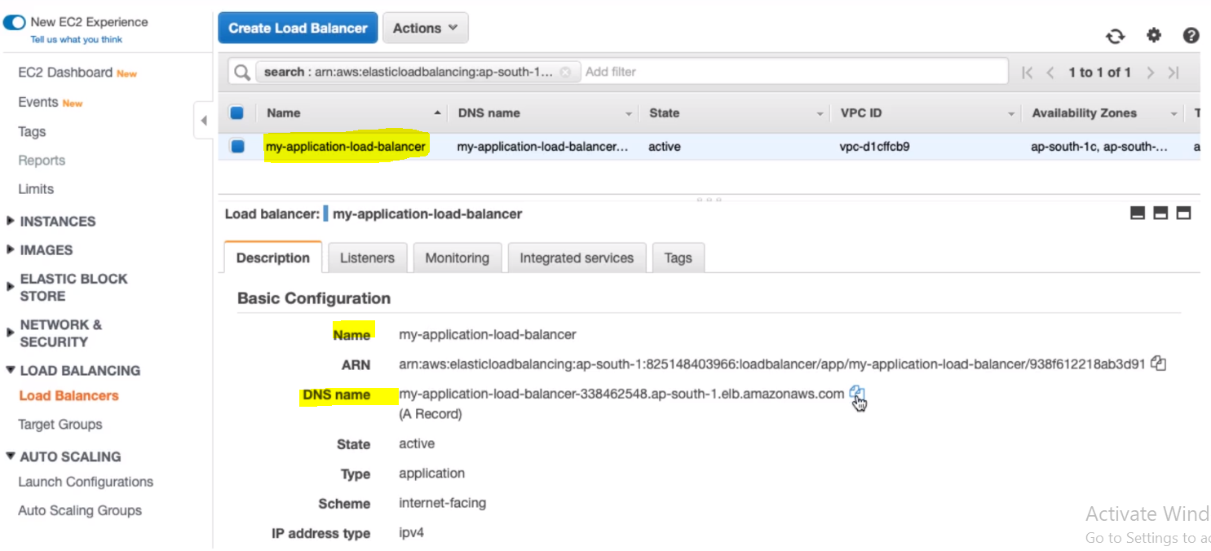

So finally we have created Application load balancer with the given name ad we have got its DNS name. Now let’s copy its DNS name and run in the browser.

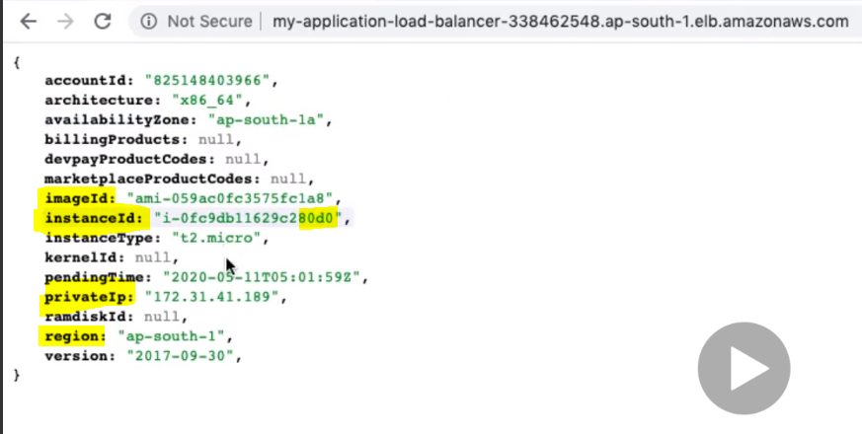

**Now if refresh the above browser.**

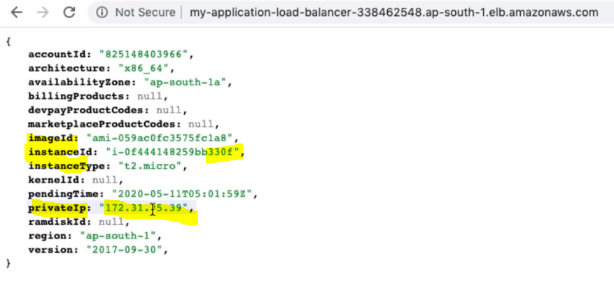

So we can see that Application load balancer is routing the request to both the EC2 instances

Note: Let’s try to run the EC2 instances through its public IP.

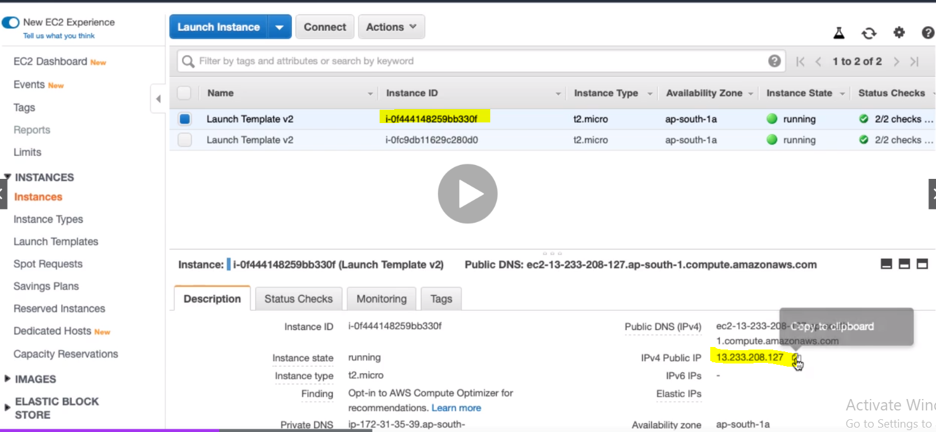

|  |  |
| --- | --- |
|  | So we are able to talk to EC2 instances directly also.  So right we are load balancing EC2 instances from the load balancer and we are able to execute EC2 directly also.  One of the most importat use of load balancer is that to secure all the EC2 instances and in that case we want to execute EC2 instances through load balancer instead exectuing directly |

So here we will block direct traffic for EC2 instances and will enable the traffic through load balancer and we will achieve this through Security Group. Let’s go to securtiy group and allow the the traffic only for the application load balaner instead of all. 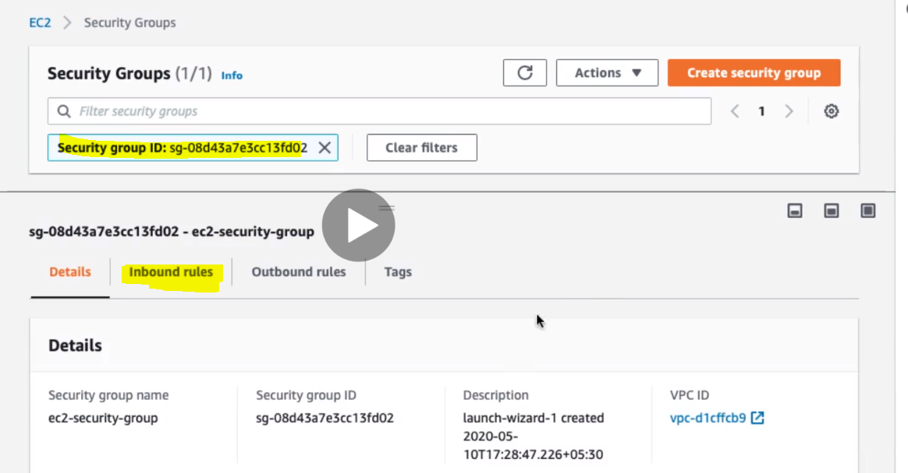

Go to inbound rules and edit

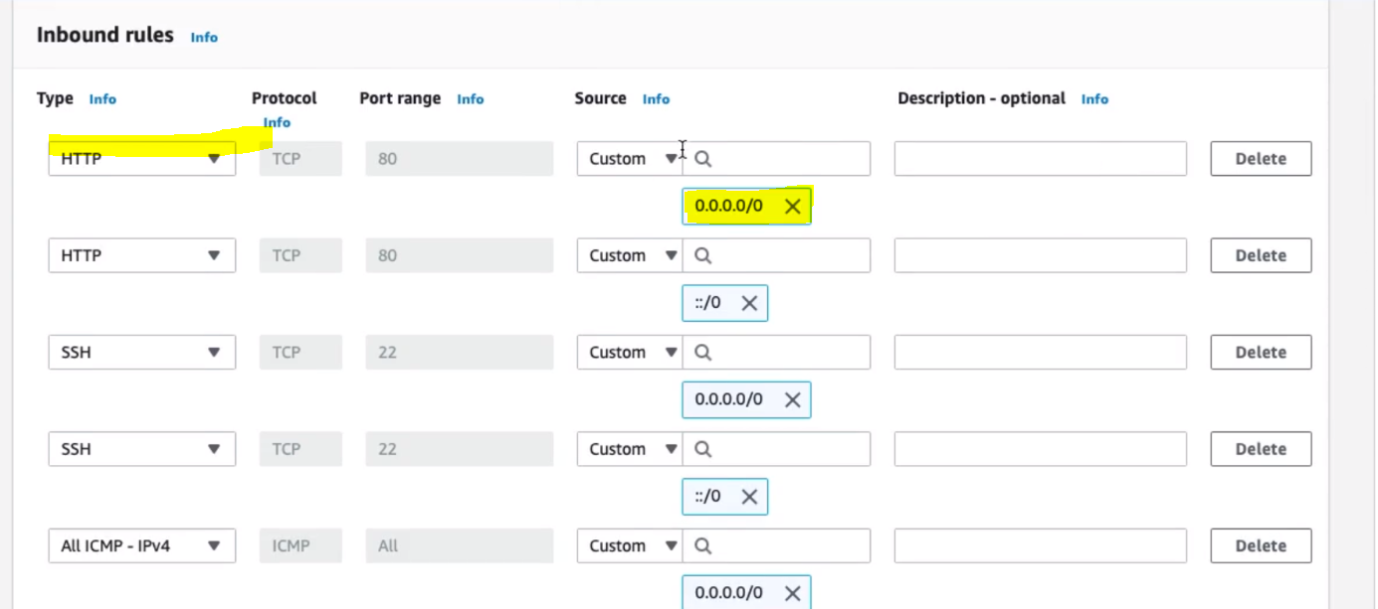

As we can see that we are allowing http request from everywhere so now instead of everywhere we would allow from application load balancer security group that we have created during A LB creation. So let’s search A LB SG in the search and select the same.

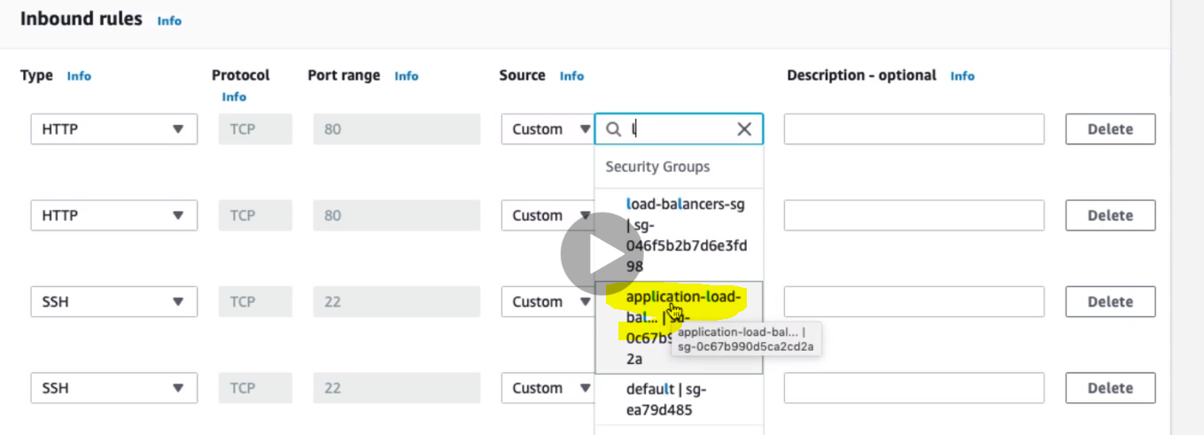So after selecting the Application Load balancer security group we have below inbound rules:

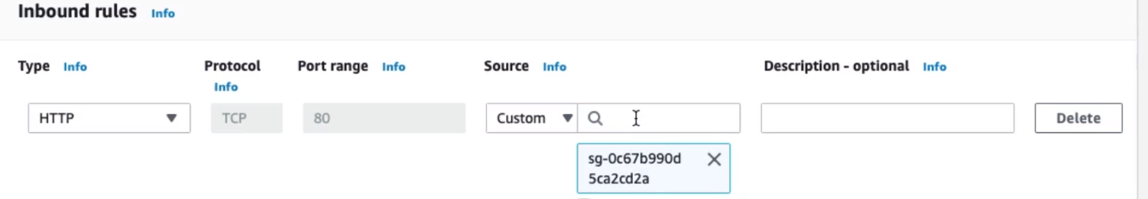

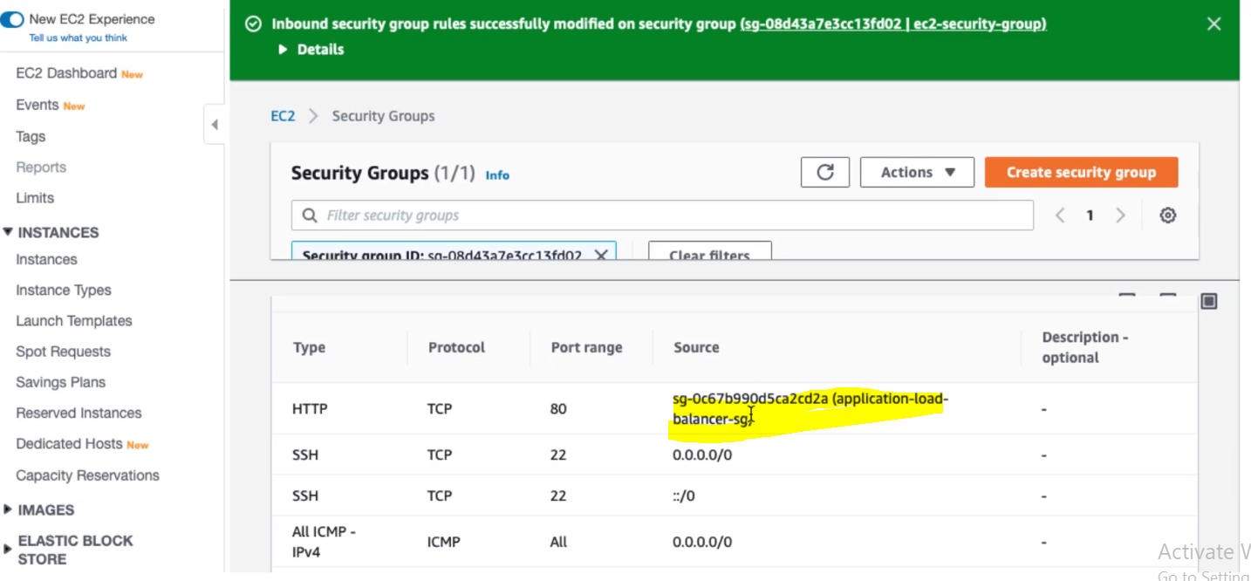

So now we have changed the inbound rule for EC2 instances and allowed its incoming request through LB

Now if we try to execute EC2 with its public IP then we will get time out but if we execute through Application Load balancer then it will execute successfully.

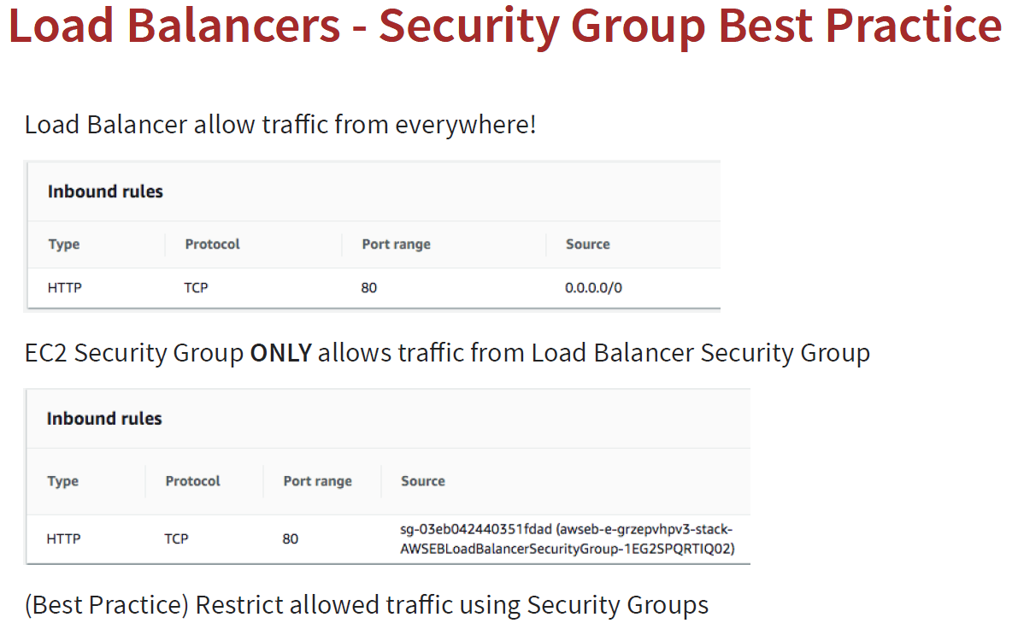

**Note**: So let’s say we have 3 tier architecture where we have load balancer, web application and database. So as per the ideal scenario Database security group should only allow the inbound traffic from web application and the web application should allow inbound traffic from load balancer. So having the different security group for each of them and using them in inbound rule is very good practice.

**44. Step 08 - Understand AWS Elastic Load Balancing Listeners**

Let’s talk about the basic concept about the load balancer like how it manages the listeners, multiple listeners, security groups, target groups (EC2 instances).

1. **Concept of Listeners:** A listener basically checks for connection request using its configured protocol and port, and load balancer uses the listener rule to route request to its targets. We can add, remove or update listeners and its rules.

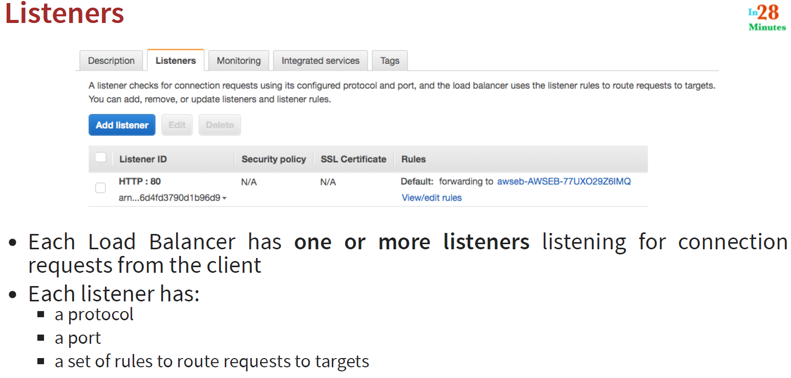

**For example in the above we are listening for http at port 80 and we are routing to a specific target group mentioned under Rules. We can have multiple listeners listening for load balancer.**

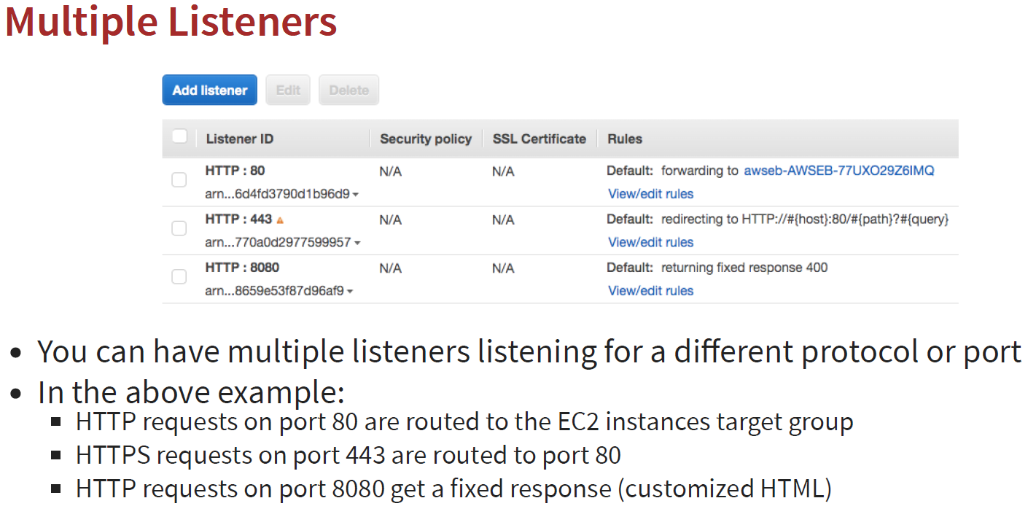

**Let’s configured the fixed response 200 with an html response:**

1. **Go to Load Balancer**
2. **Go to its listeners tab**

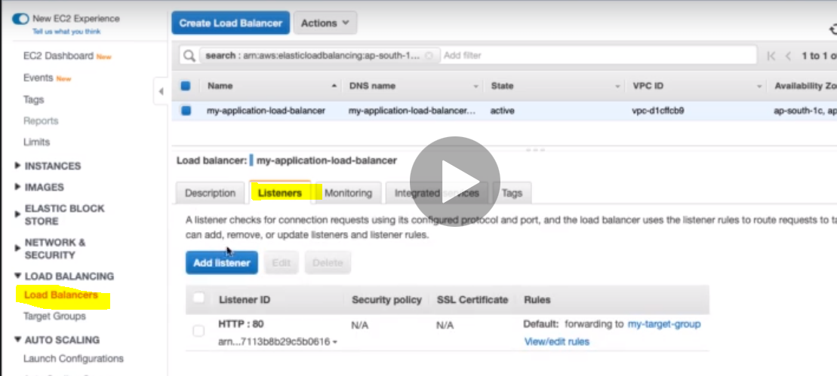

1. **Click Add listener and select protocol and port number 8080 and under Add Action click on Return fixed response**

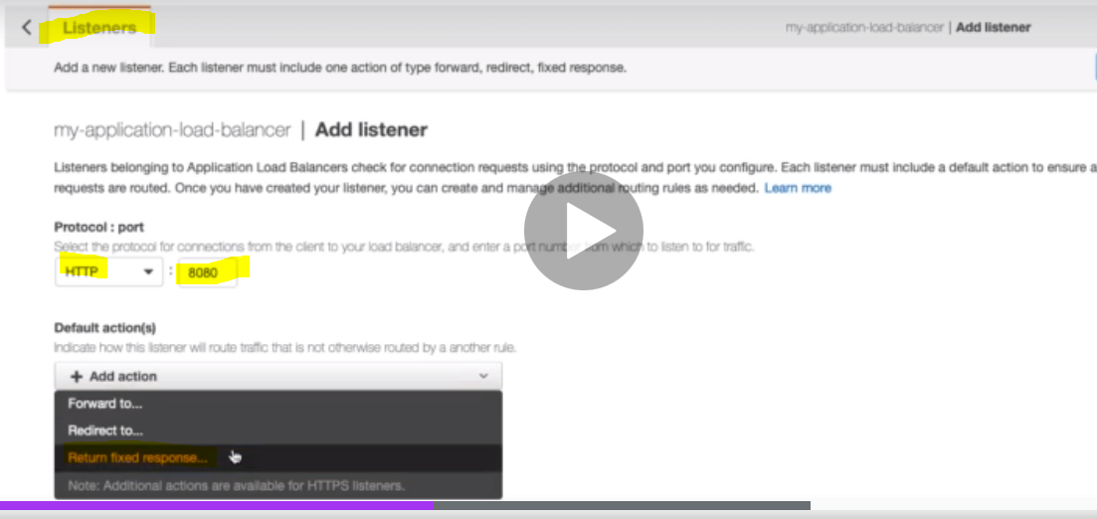

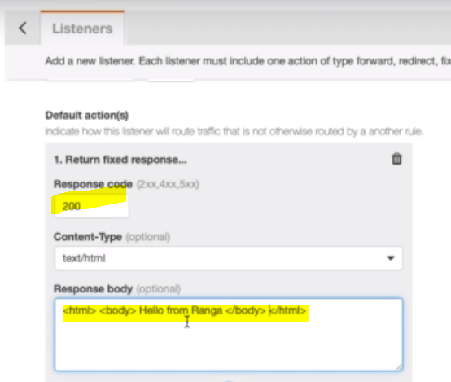

**Now when we get success response then we will get this fixed response.**

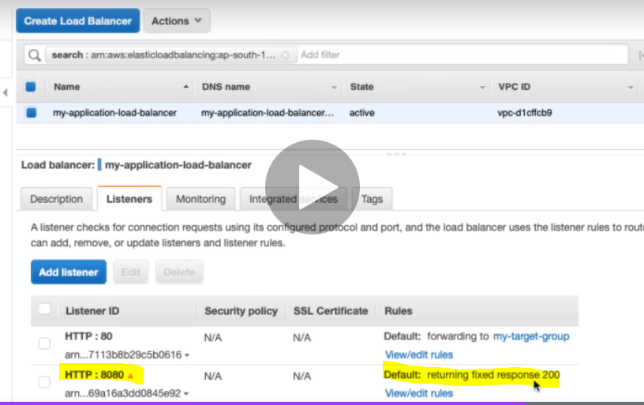

**The default http port is 80 but here we have given port 8080 so let’s add this in the security group of application load balancer.**

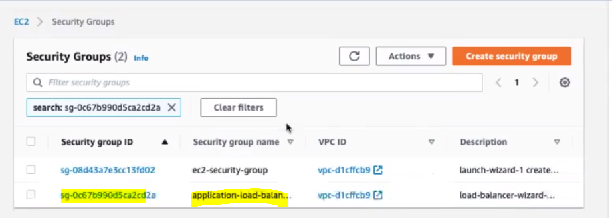

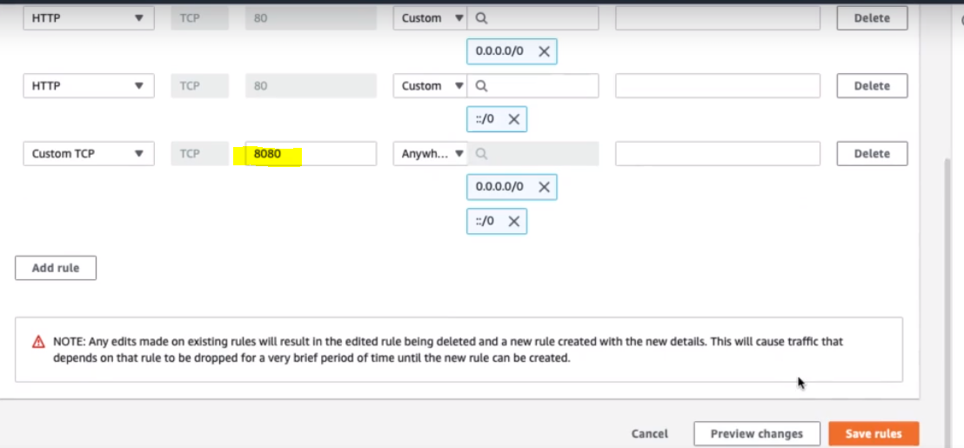

**Now if we execute A LB DNS at port 8080 then we will get fixed response as given below.**

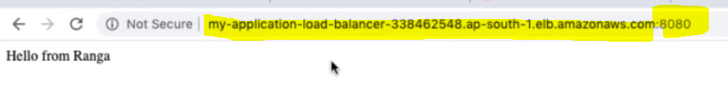

**So in this way we can add fixed response to the load balancer.**

**45. Step 09 - Exploring Application Load Balancer Target Groups**

As in the previous section we have created a group of target to be balanced by ALB. So here we will see.

* How to group instances that ALB has to distribute the load between?
* Create a Target Group: i.e. if we want to distribute the load to all the EC2 instances then we would create a target group of these EC2 instances and configure the elastic load balancer to distribute the load to the target group. We can add, delete the EC2 instances from the target group and load balancer will distribute the load only to instances available in the target group

|  |  |
| --- | --- |
| * A target group can be: * A set of EC2 instances * A lambda function * Or a set of IP addresses |  |

Let’s go to target groups:

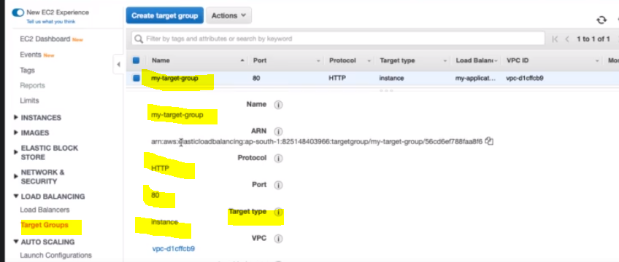

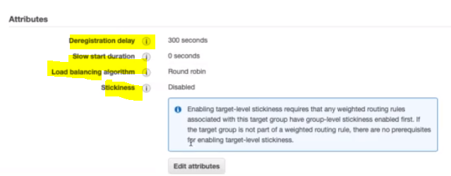

As here we can see four very important Attributes related to Target groups;

1. Deregistration Delay:

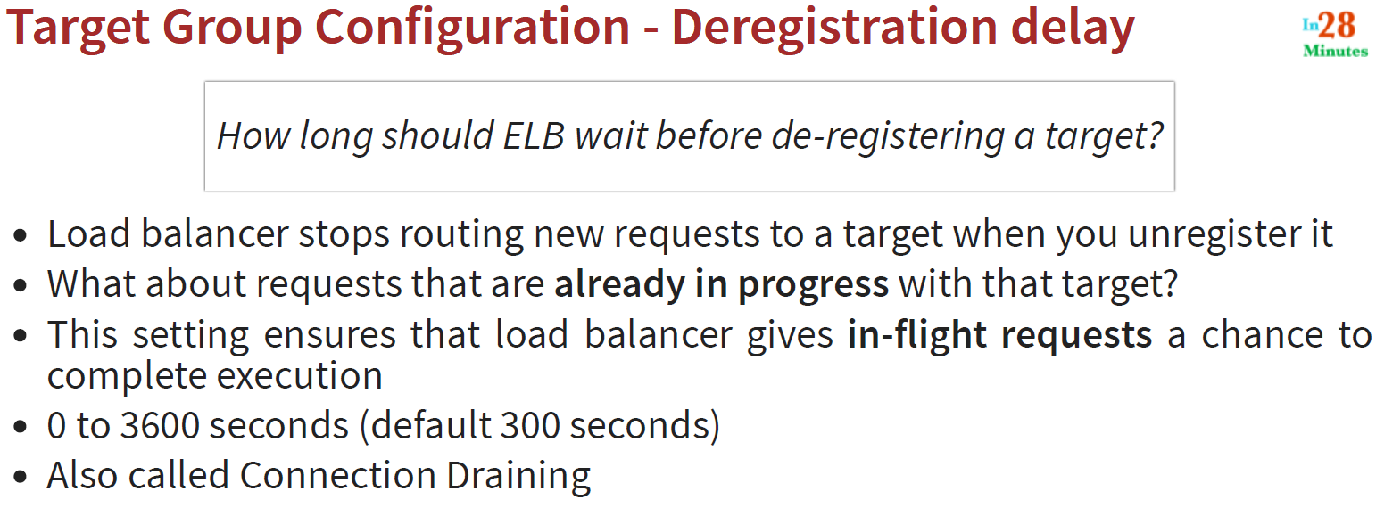

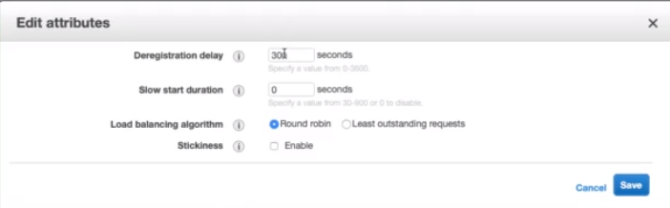

Here slow start duration is nothing but ensuring that the newly added target can get sufficient time to start handling the request when it receive very first time.

We can select the load balancing algorithm by default Round robin is enabled.

The last attribute is Stickiness which plays very important role for the target group. As we know that in case of web application most of the time we have to maintain sessions let’s say ELB distributing the load to number of EC2 instances and we have a number of users who are sending requests to it and in this case few instance wants to ensure that the request for the same user go to the same instance I.e. for a specific user want their request to go to specific instance and this is possible with the help of sticky session. We can enable the Stickiness by enabling the parameter.

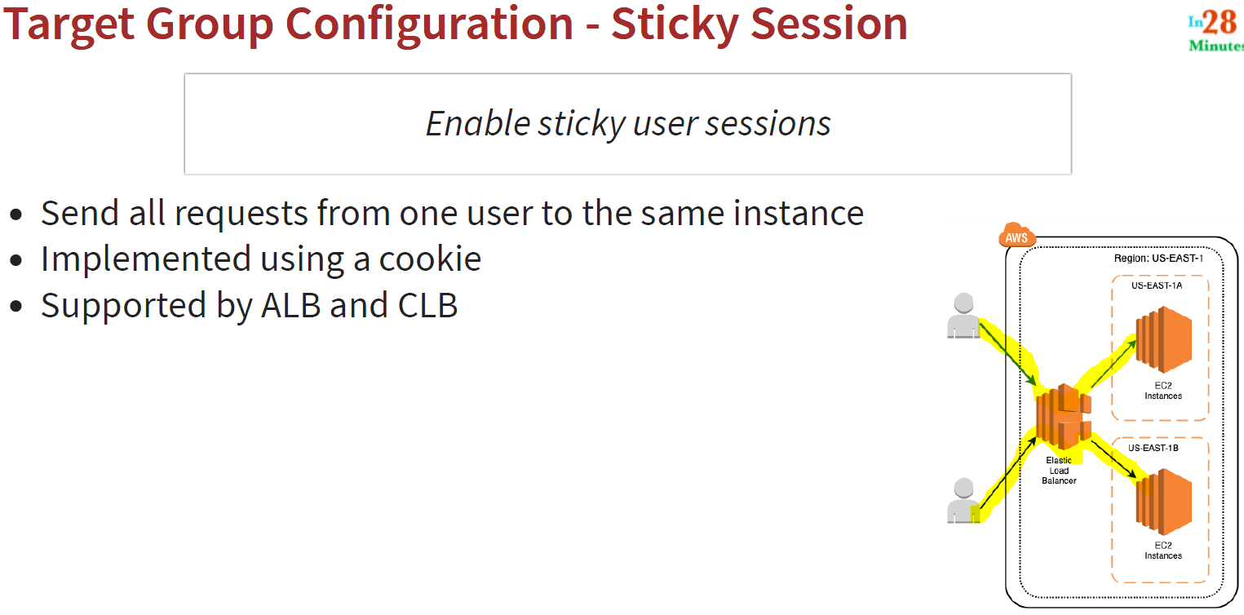

**Step 10 - User data for microservice**

|  |
| --- |
| 1. #!/bin/bash 2. curl -s http://169.254.169.254/latest/dynamic/instance-identity/document > /var/www/html/index.html 3. mkdir /var/www/html/a 4. echo “Microservice A” > /var/www/html/a/test.html |

**47. Step 11 - Using Multiple Target Groups for Microservices Architectures**

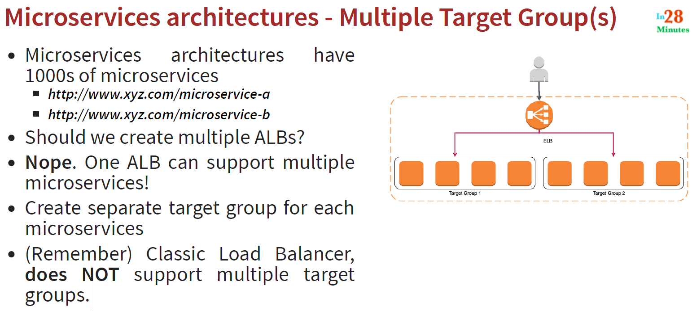

Q: Now if you have multiple target groups then how do you route to them?

A: Using multiple listener rules using IF- THEN condition

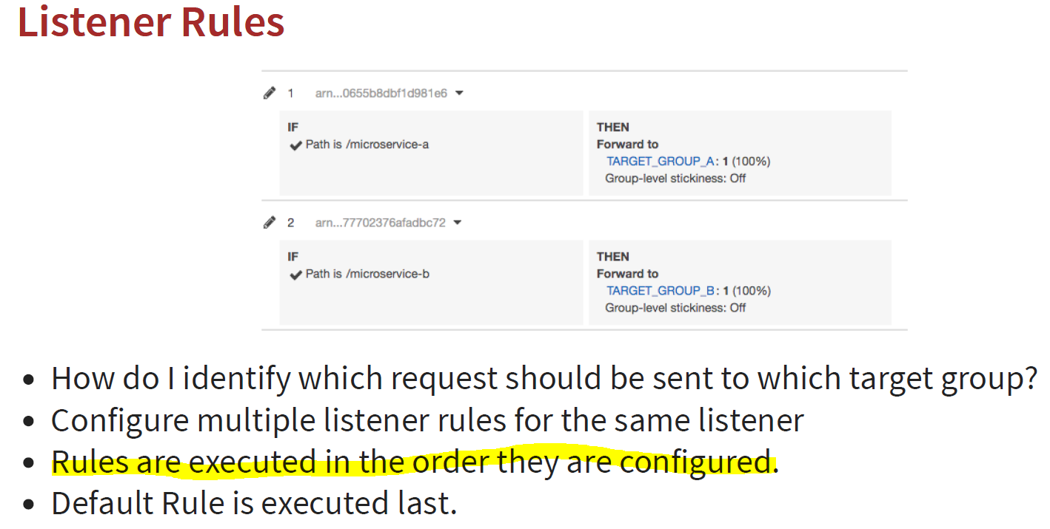

**Step 12 - Exploring Listener Rules in ALB**

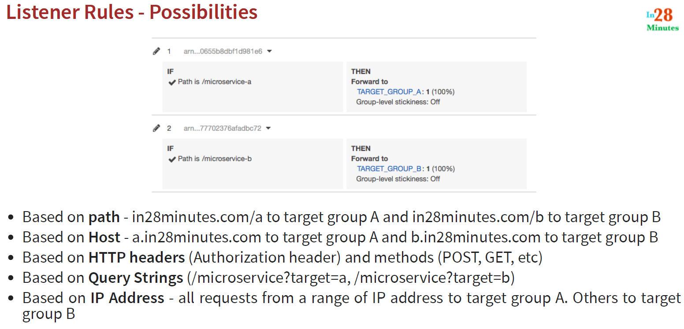

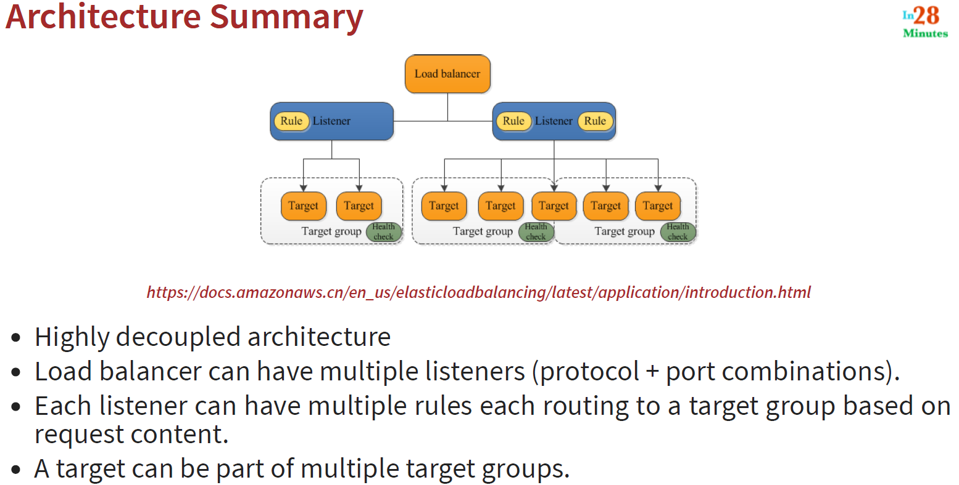

**49. Step 13 - Getting started with Auto Scaling Groups**

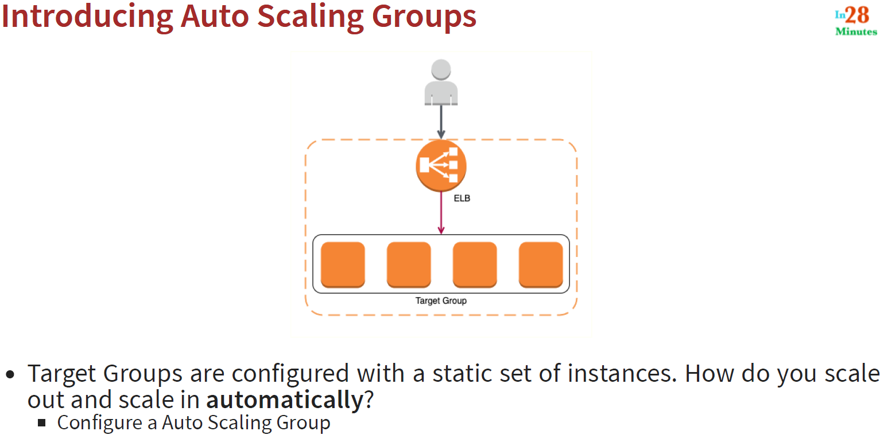

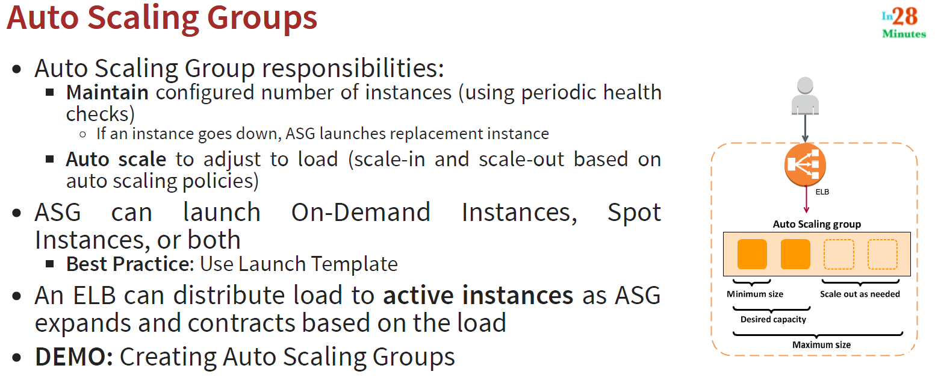

**50. Step 14 - Creating Your First Auto Scaling Group**